ECT286 Final Project Report

**Conveyor Belts Using PLC**

This project counts and packs objects from a Conveyor belt

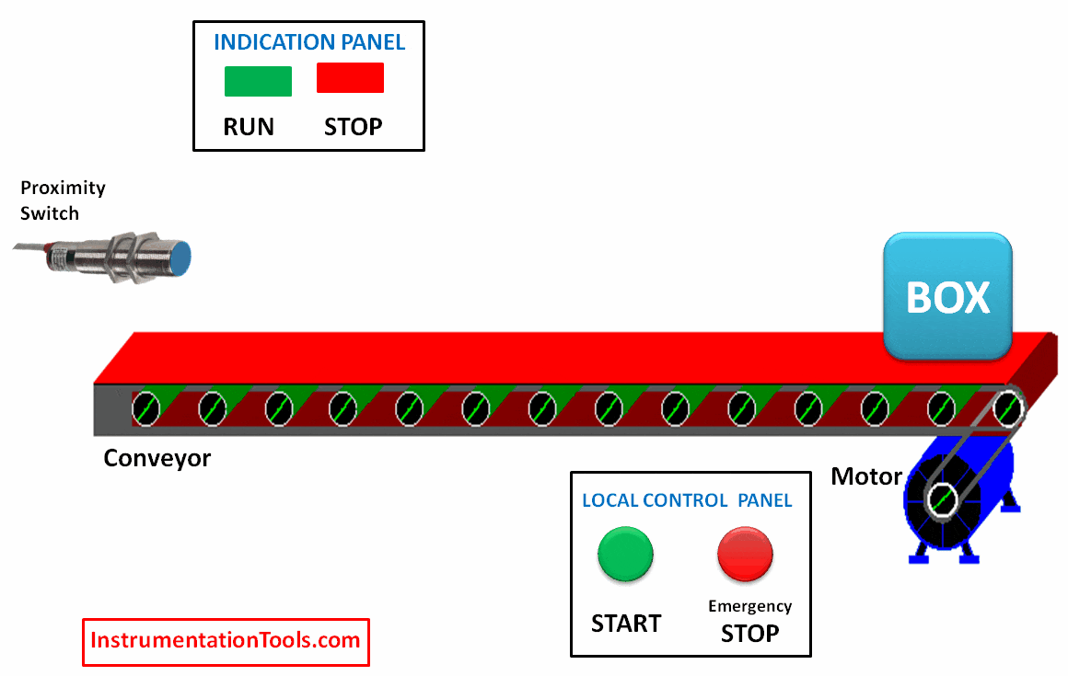

Eric Ocasio

ECT286

Professor: Mohamed Brihoum

DeVry University

College of Engineering and Information Sciences



February 2022

Executive Summary

My project is project covers controlling a simple DC motor with an integrated sensor for feedback control. While utilizing Ligixpro PLC simulator to develop a ladder logic program and create applications for Flashing Lights and detecting objects in a moving conveyor belt. PLCs are called Programmable Logistic Controllers in other words an industrial computer control system that continuously monitors input devices such as a thermostat, automatic doors, elevators, roller coasters, etc. PLCs also make decisions based on a custom program to control output devices.

Table of Contents

Introduction 1

Project Description 1

Project Objectives 1

List of Material 1

Project Design 1

Test Results 1

Lessons Learned 2

Author's Biography 2

Works Cited 2

Work Consulted 2

Appendix A 2

Appendix B 2

Appendix C 2

# Introduction

In this project, I will use proximity switches to detect moving objects on one conveyor belt and to detect an empty box on a second conveyor belt, as well as to use timers to stop the conveyor belt when the number of objects per empty box is reached and packed. This project is to show what can be done using Programmable Logistic Controllers and how automation is something that is already in our day-to-day lives by making all our lives easier using PLC applications.

# Project Description

I will make timed conveyor belts using timers, switches, latching motors, etc., to package objects into empty boxes and have the conveyor be autonomous through the Proteus simulator and Ligixpro- Programmable Logic Controller simulation tools.

# Project Objectives

The Project objective, I will use timers so that when five pieces are detected, the conveyor runs and stops when 5 objects are finally collected in the box when the number of objects is packed the detected timer is activated. When the timer is over, it stops the conveyor until the next empty box is detected

# List of Material

I:1/14 = Start (Input)

I:1/15 = Stop (Input)

B3:0/0 = Latching Bit (Bit)

B3:0/1 = Latching Motor 1 bit (Bit)

I:1/0 = Object detection (Input) Proximity Switch

I:1/1 = Box detection (Input)

O:2/1 = Conveyor Belt 1 (Output)

O:2/0 = Conveyor Belt 2 (Output)

C5:0 = Object counter (Counter)

T4:0 = Timer to stop conveyor (Timer)

Proteus simulator

Ligixpro- Programmable Logic Controller simulation tools

# Project Design

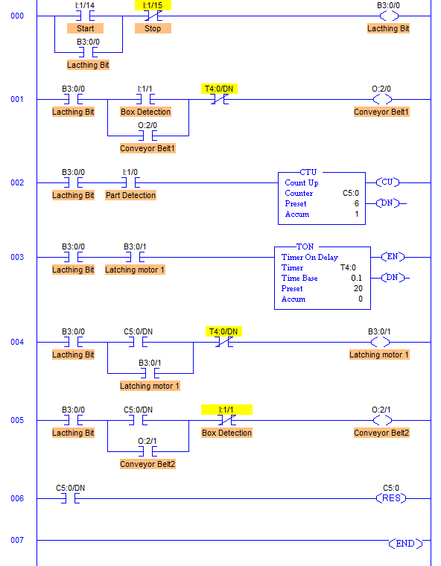

# Test Results

Conveyor Belt 1 moving 5 objects into box

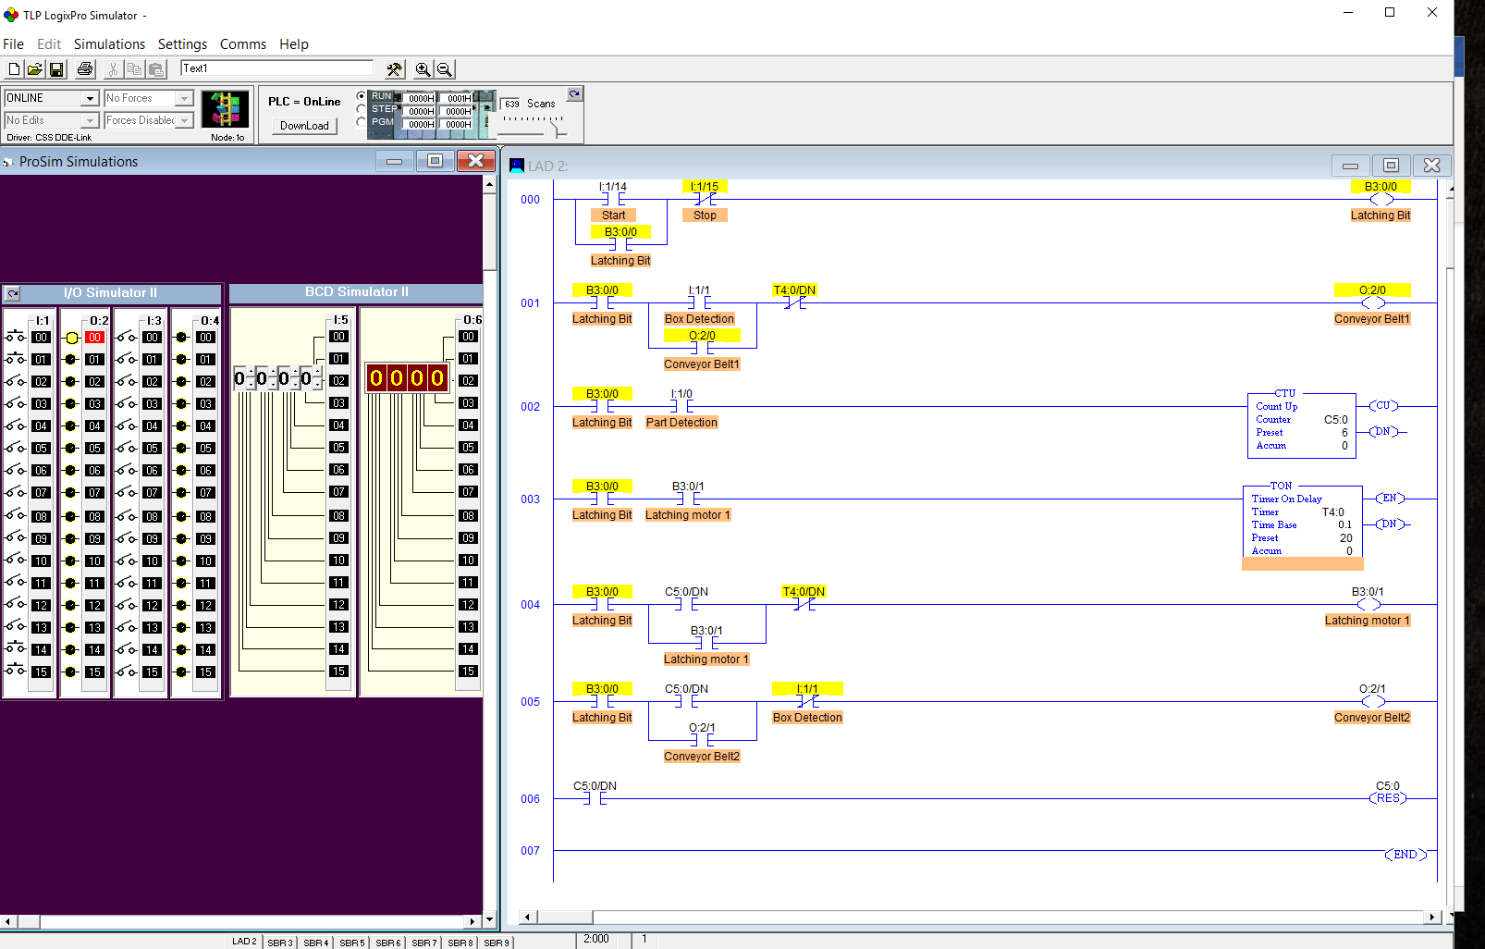

Conveyor Belt 1 Box full starting Conveyor Belt 2

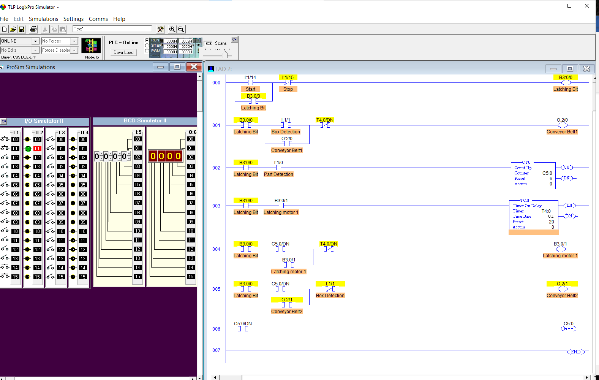

# Lessons Learned

I Learned that proximity switches can be set up in Ligixpro through coding and matching lights to switches. Something I would do differently would be to experiment around with Ligixpro even more to get a deeper understanding of the system.

# Author's Biography

I work at Menard’s; I was always good at fixing things and building things. A career goal of mine is to generate passive income or such, a way for me to enjoy my youth without having to waste my talents in a 9 to 5 setting.

# Works Cited

[1] How plc applications impact our daily lives. How PLC Applications Impact Our Daily Lives | George Brown College. (n.d.). Retrieved October 22, 2022, from https://www.gbctechtraining.com/blog/world-plcs-closer-you-think-plc-applications-our-everyday-lives

[2] Ladder logic examples and PLC programming examples. PLC Academy. (2020, June 3). Retrieved October 22, 2022, from https://www.plcacademy.com/ladder-logic-examples/

[3] What is a programmable logic controller (plc)? TechTalk Blog. (2021, September 10). Retrieved October 22, 2022, from https://www.polycase.com/techtalk/electronics-tips/what-is-a-programmable-logic-controller.html

# Work Consulted

Aleksey Antonov

Professor Mohamed Brihoum

# Appendix A

# Datasheet on Rockwell Automation for Programmable Logic Controllers (PLC) - *Allen-Bradley / Rockwell Automation*. Allen-Bradley / Rockwell Automation Programmable Logic Controllers (PLC) Data Sheets | Engineering360. (n.d.). Retrieved October 22, 2022, from https://datasheets.globalspec.com/ds/714/AllenBradleyRockwellAutomation

# Appendix B

Good afternoon, Aleksey,

Your project was very well written I had no idea what was being asked by explaining the project multiple times in the introduction, description, and objective but by the way, you explain it seemed to be more of an overview, details on used equipment, and the actual guide to the project only thing I could really find as a fault though minor was the works cited page as it only has two websites and the image used without being formatted. As such for helping me understand this better I added your name to my work consulted to credit you.

I use this webpage to site everything, hope it helps you https://www.citationmachine.net/apa/cite-a-website/new