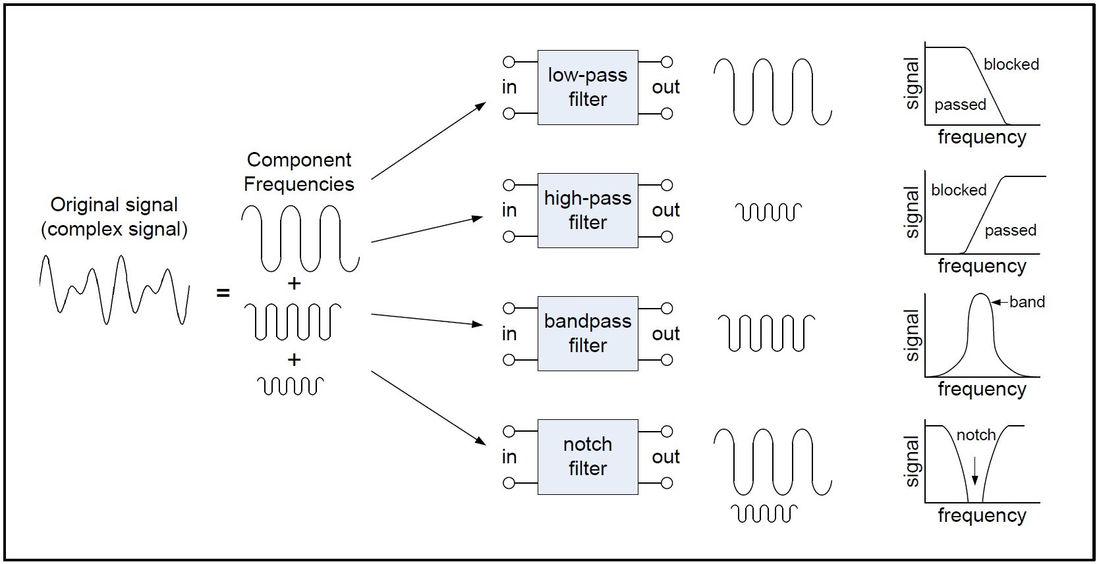

Final Project
An introduction to filters - technical articles. All About Circuits. (n.d.). Retrieved December 17, 2022, from https://www.allaboutcircuits.com/technical-articles/an-introduction-to-filters/

  - ECT226
Eric Ocasio | November 2022 | 12/16/2022

Introduction
Objectives
- Investigate how the low-pass, high-pass, and band-pass filters work.
- Learn to construct and troubleshoot the active filters using Multisim.
- Learn to calculate and measure the voltage gains and critical frequencies of the filters.
- Understand active and passive filters

Active Filters vs. Passive Filters
Discuss the function of the filters. Introduce and compare passive and active filters. Explain why active filters are most used in the circuit design. List a few important applications of active filters. Please include pictures/diagrams/graphs as needed. Word count: 150 to 300 in your own words or appropriately cited.

The difference between active and passive filters is that Active filters require a power source to operate, while passive filters do not require a power source to operate. Another difference between Active filters and passive filters is that Passive filters are
built from passive components like resistors, capacitors, and inductors, Wile Active filters are used more for components like amplifiers. Active filters are used more in circuit design by the fact that Active filters have an advantage over passive versions by including the ability to provide signal gain, having higher input and lower output impedances, and having no need for buffer amplifiers. An important application for active filters is the fact that they are used in audio systems to send frequencies to speakers and are used in music to change the frequency of components. Active filters are also used in walkie-talkies. These are just some of the uses we use active filters in circuit design

Procedures and Results

Follow detailed instructions provided in the Procedures of the ECT226 Final Project Guide.
- Determine the type of the filter from the given frequency response (Part 1, step 1).
Type of the filter: High-Pass

- Calculate $f_{c}$ and $A_{CL} . Enter$ the values in Table 1 (Part 1, step 4).
 | Table 1
Calculated $f_{c}$ (kHz) |  | Calculated $A_{CL}$@ pass band | Calculated $A_{CL}$(dB) @ pass band
7.957 KHz |  | 2 | 6.02db

- Measure $f_{c}$ and $A_{CL}\left(dB\right). Enter$ the values in Table 2 (Part 1, step 9).
 | Table 2
Simulated $A_{CL}$(dB) @ pass band |  | Simulated $f_{c}$ (kHz)
40.9 dB |  | 2.771 KHz

- Paste two screen shots: a) Schematic design; b) Simulation result (Part 1, step 14).

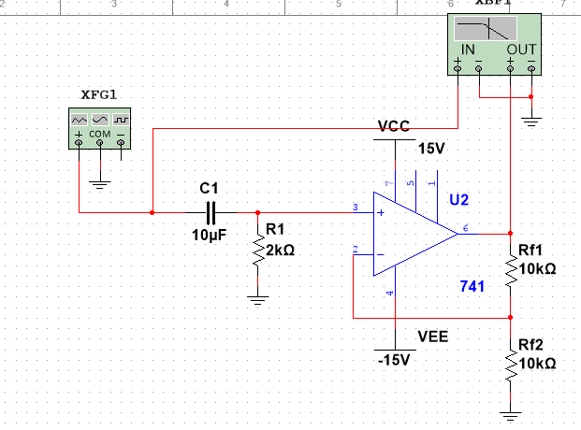
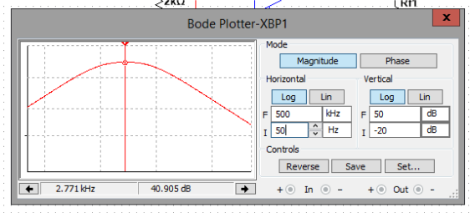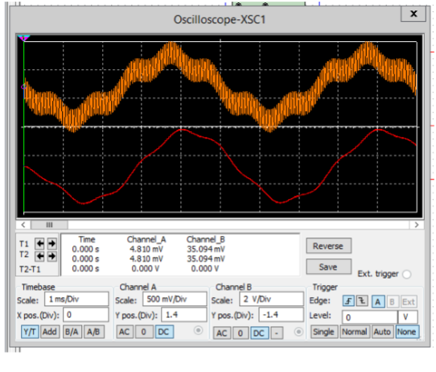

- Explain the output of the low-pass filter. Which frequency component(s) are filtered out? Why? (Part 1, step 15).

Low frequency signals from 0Hz to the cut-off frequency, removes unwanted frequency
Past a certain determined cut-off frequency.

- Paste two screen shots to show: a) the band-pass filter simulation circuit; b) the frequency response curve and setting on the Bode Plotter (Part 2, step 4).
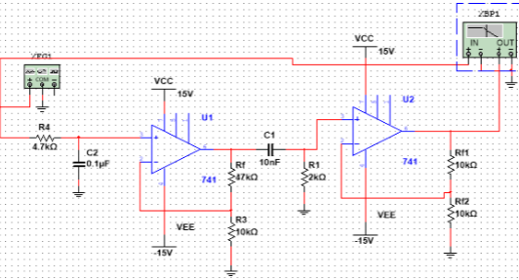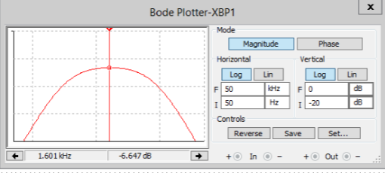

- Measure $f_{cl}$ and$f_{ch}$ from the simulation. Fill in the values in Table 3 (Part 2, step 5).
 | Table 3
Measured $f_{cl}$ (Hz) |  | Measured $f_{ch}$ (kHz)
388.22 Hz |  | 1.601 KHz

Conclusion
Summarize what you observed and learned from this project. Describe the problems you encountered and how you solved them. (50 to 100 words)
I learned that we use mostly Active filters in circuits compared to Passive filters, I had a few problems plotting my circuits but with a bit of patience was able to get results in the plotters. I used the guide and the videos and somehow made it through the projects.

References
- Text book
- Datasheets
- Internet sites, etc.

